1.Install essential software.

1. dotNetFx45_Full_setup.exe
2. SpansionJtagFlashprogrammer_2015.9.173.6.exe
3. chsp-17_3912483_S.exe
4. Setup_JLink_V498d.exe

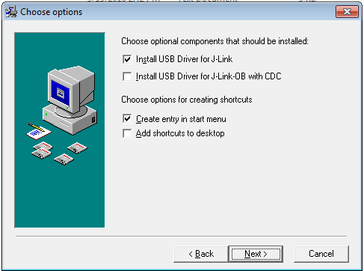

2.How to Connect

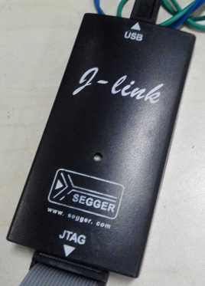red line indicate white dot on board

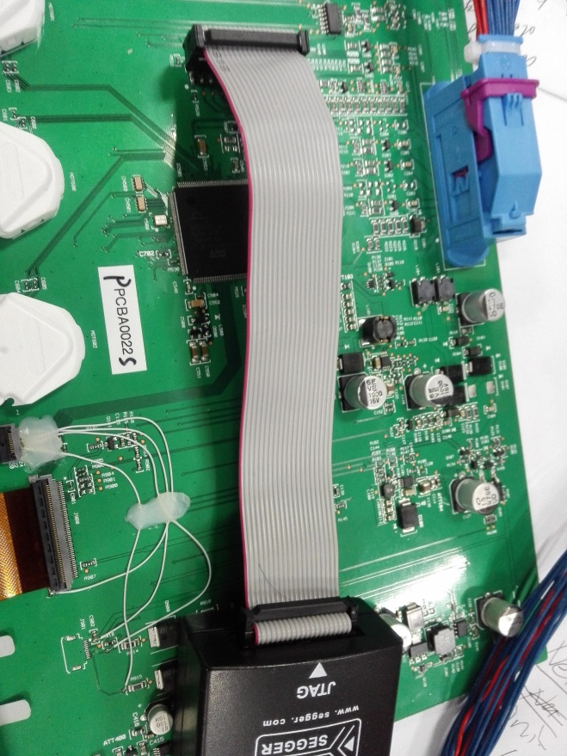

2.Procedure to flash hyperflash using J-Link

1. Unzip **chsp-17_3912483_S.zip** and install the Jlink tool - It will install in - C:\Program Files (x86)\Spansion\FPRG
2. Copy **ch2_40M.MCXML** under “FPRG” folder
3. Copy BAIC_DV_InternalFlash.MCXML under “FPRG” folder
4. Copy BAIC_DV_Hyp0.MCXML under “FPRG” folder
5. Copy J-LinkProg.bat under “FPRG” folder

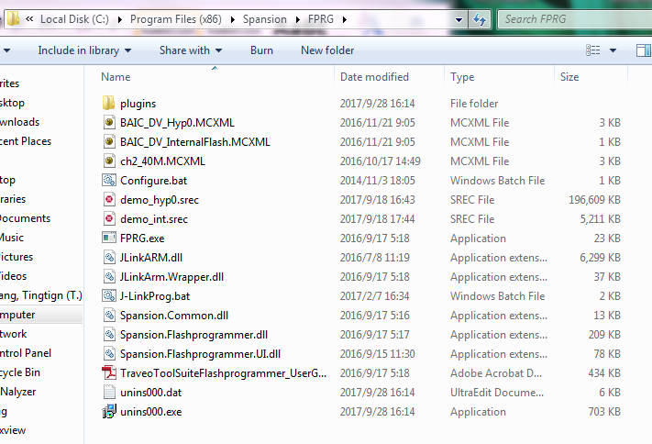

3. Copy “**Custom.JLinkScript**” under

-         “C:\Users\*your PC user name*\AppData\Roaming\Spansion\FPRG” (hidden folders should be viewable)

If the your don’t have this folder, please create it manually.

**How to make unhide folders see below**

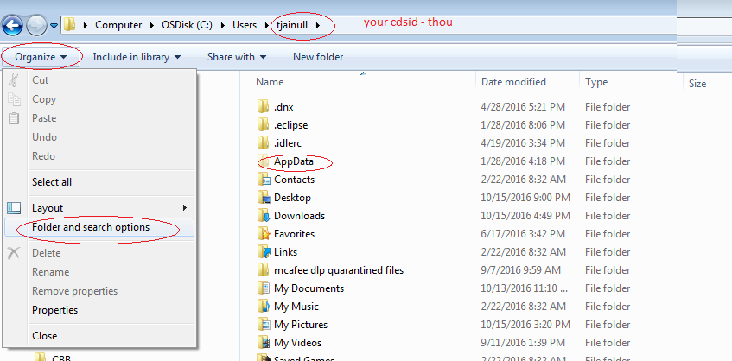

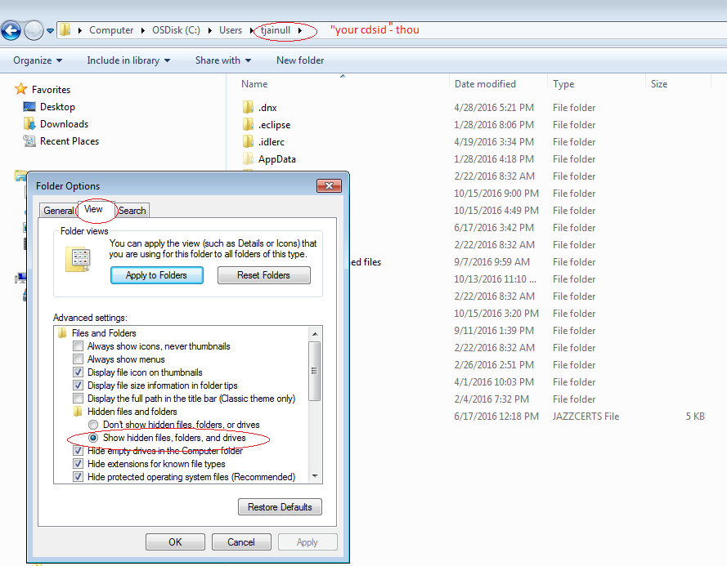

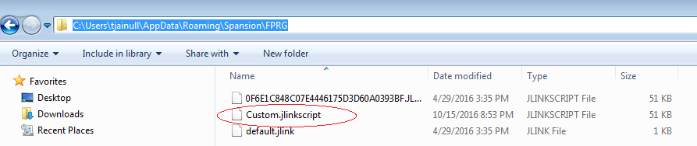

1. Go to command prompt and give the below command for programming

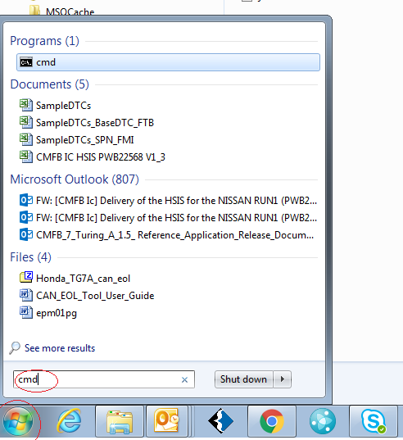

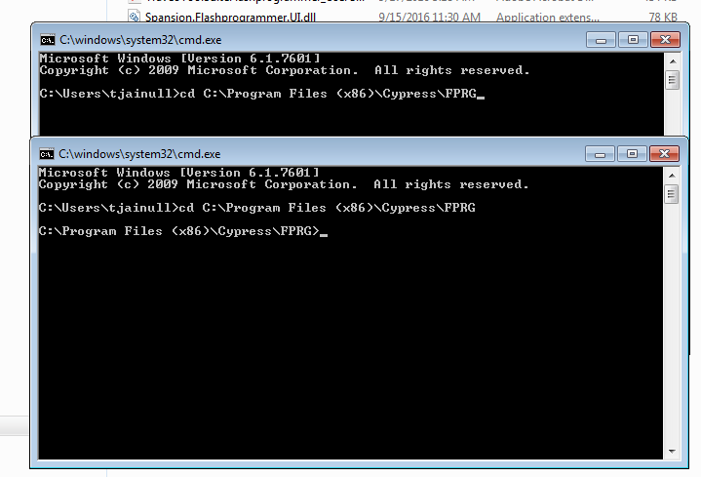

1. Give the command for hyperlfash 1

Fprg -PerformWrite -MemoryDriverConfig=ch2_40M.mcxml -SRecFile=**demo_hyp0.srec**

-          When you run FPRG next time, you should see a message indicating that Custom.JLinkScript is being run.

Verify below final output as below

